## Module – 1 Compute

**Assignment 3:** Migrate your instance from One Region to Another Region

Synopsis: I want to move or copy my Amazon Elastic Compute Cloud (Amazon EC2) instance to another subnet, Availability Zone, or virtual private cloud (VPC).

Use the two methods for migrating the instance:

1.Use the AWS Systems Manager automation document AWSSupport-CopyEC2Instance.

2.Manually copy an instance and a launch a new instance from the copy.

## Task 1 – EC2 migration using AWS System Manager automation document AWSSupport-CopyEC2Instance

To work with SSM, we have taken steps from role creation to SSM host management creation and document execution. Below are the details and snap of every step:

Step 1: Go to IAM dashboard, click on roles and create roles-

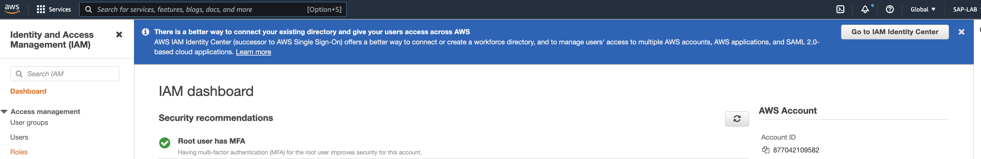

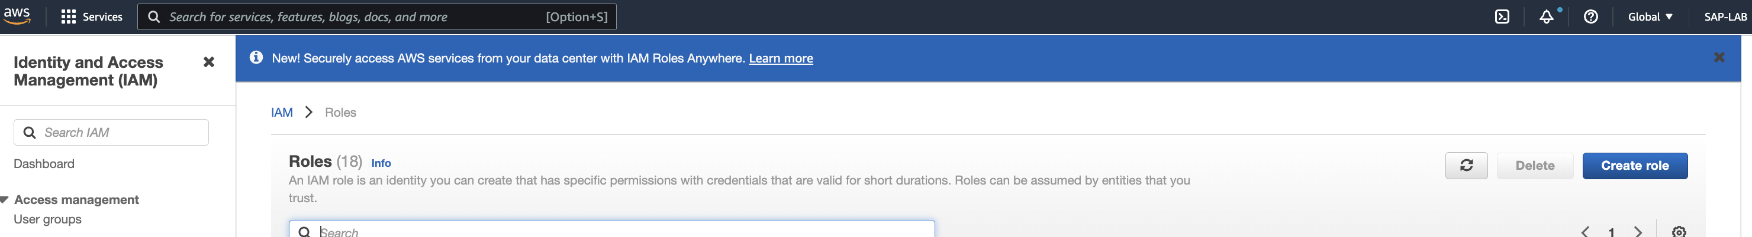

Step 2: Under select trusted entity, click on ‘AWS service’, under use case choose ‘ec2’ and click next

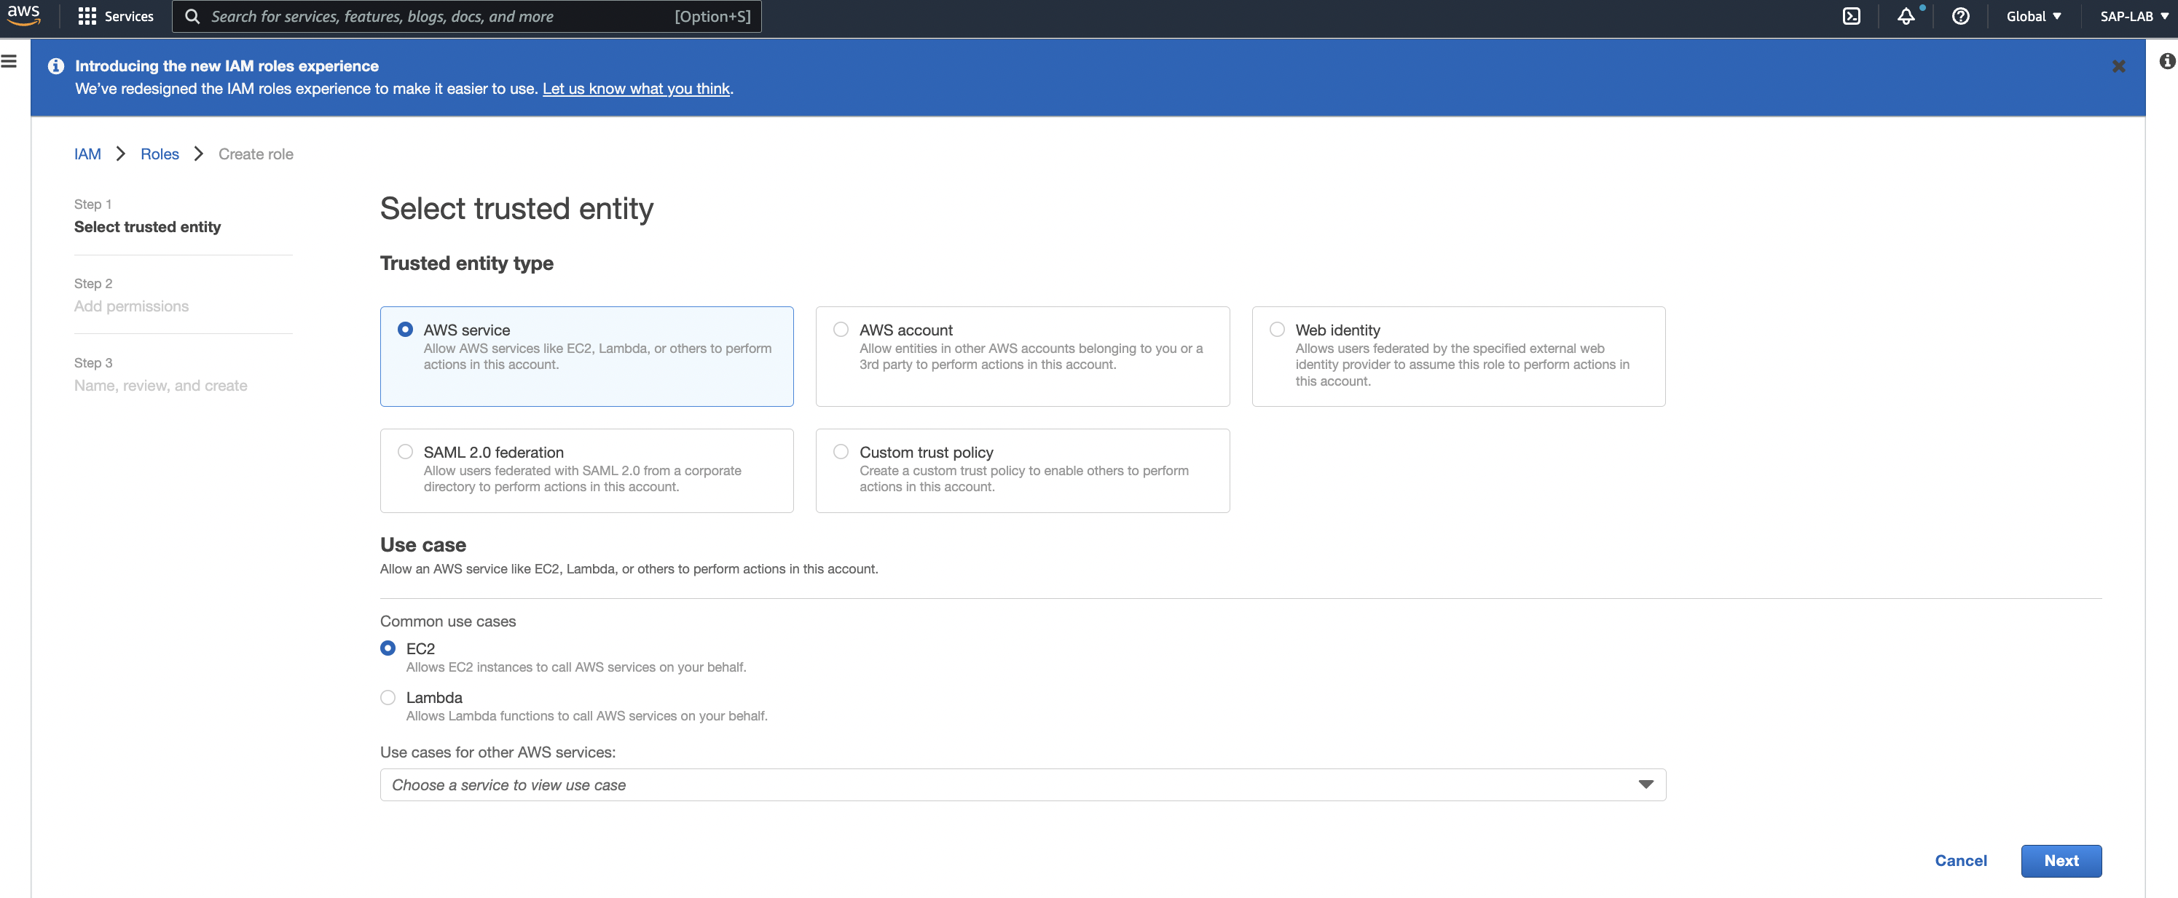

Step 3: Search and select ‘AmazonEC2RoleforSSM’ and click next.

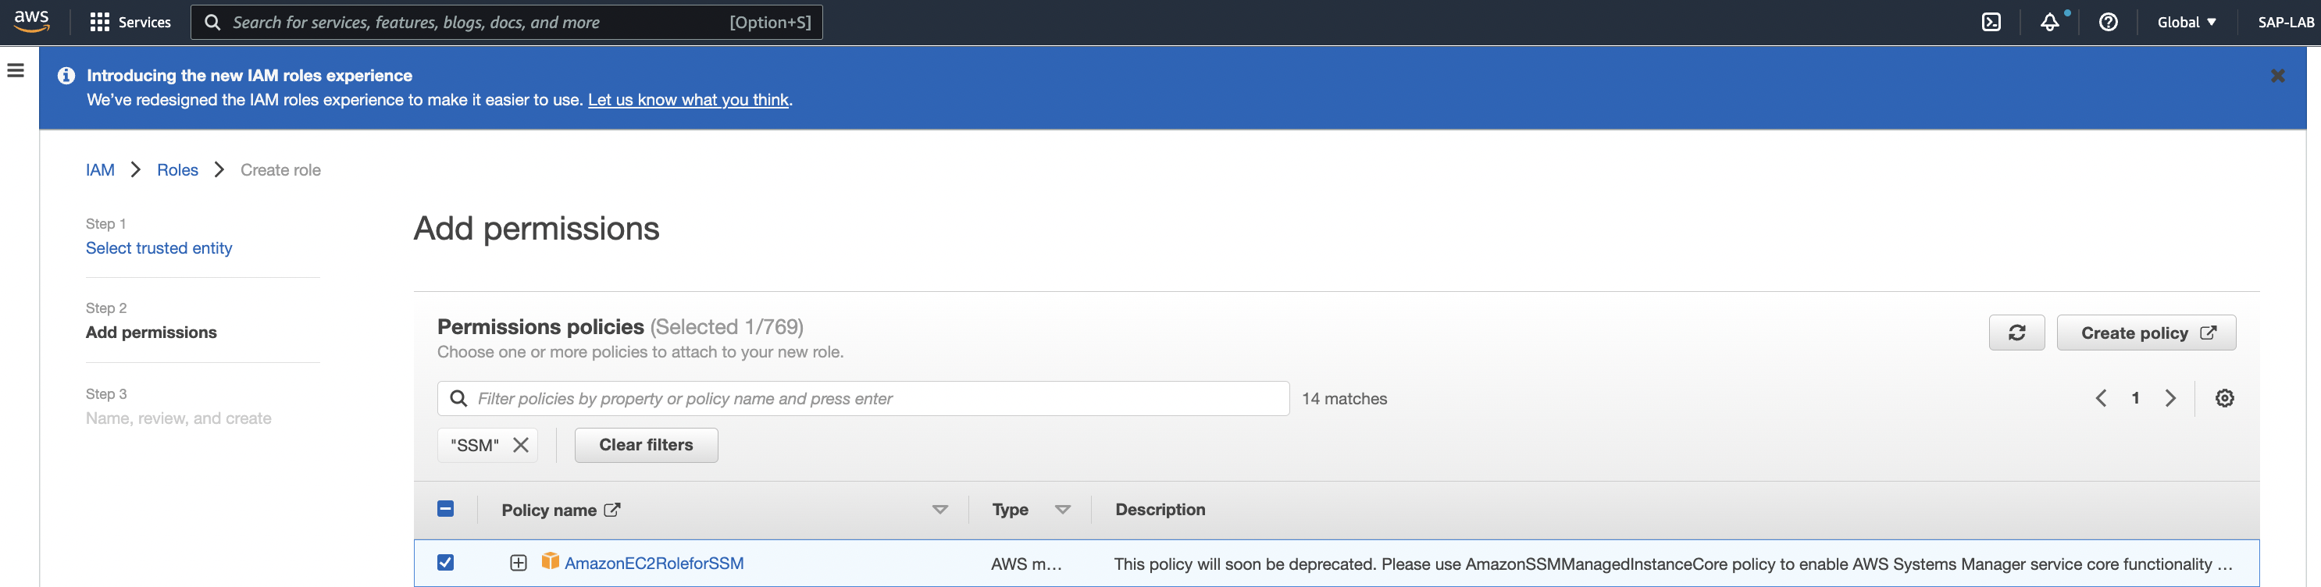

Step 4: Configure below details and Click on **Create Role:**

1. Role name – Provide the role name
2. Description – leave it as it is.
3. Tags – put the key-value details(optional)

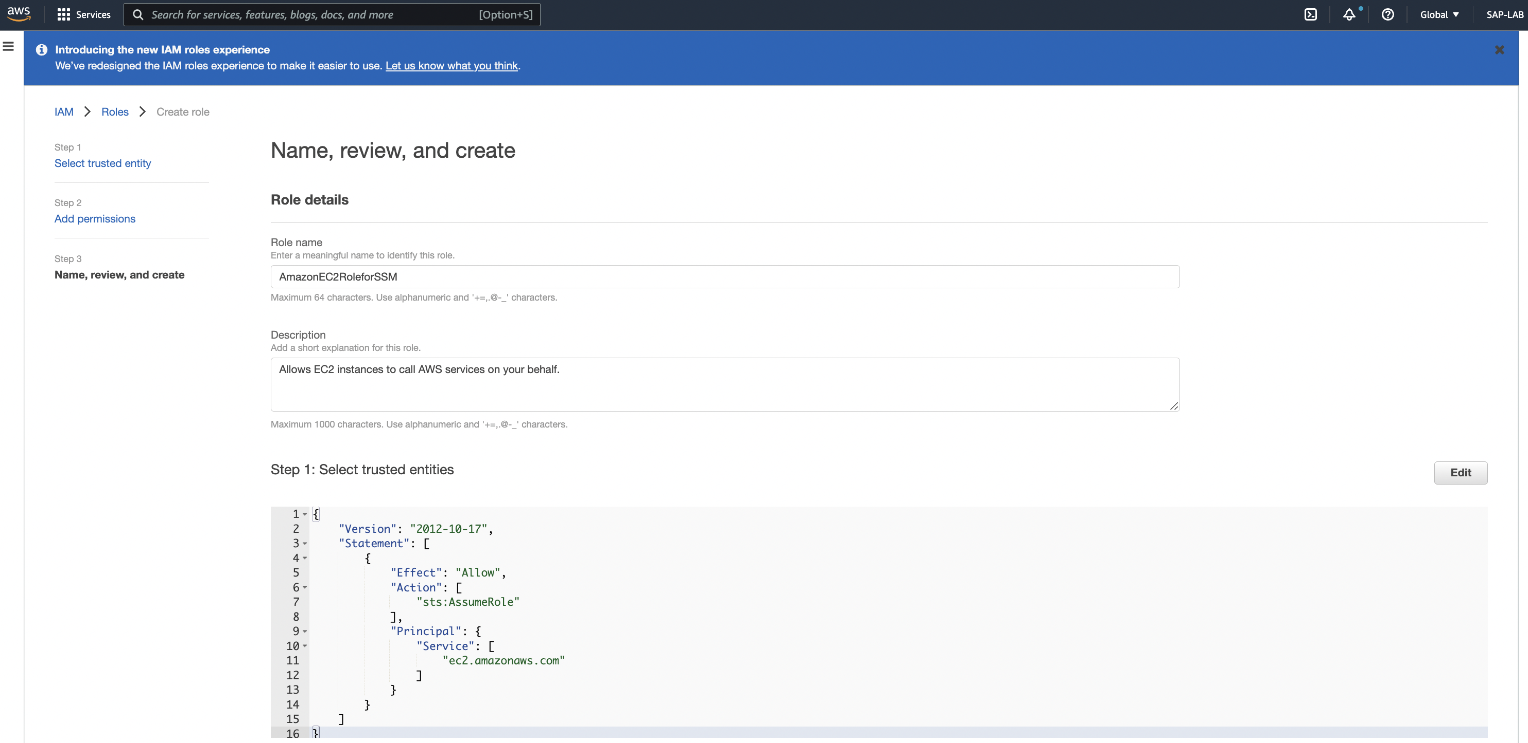

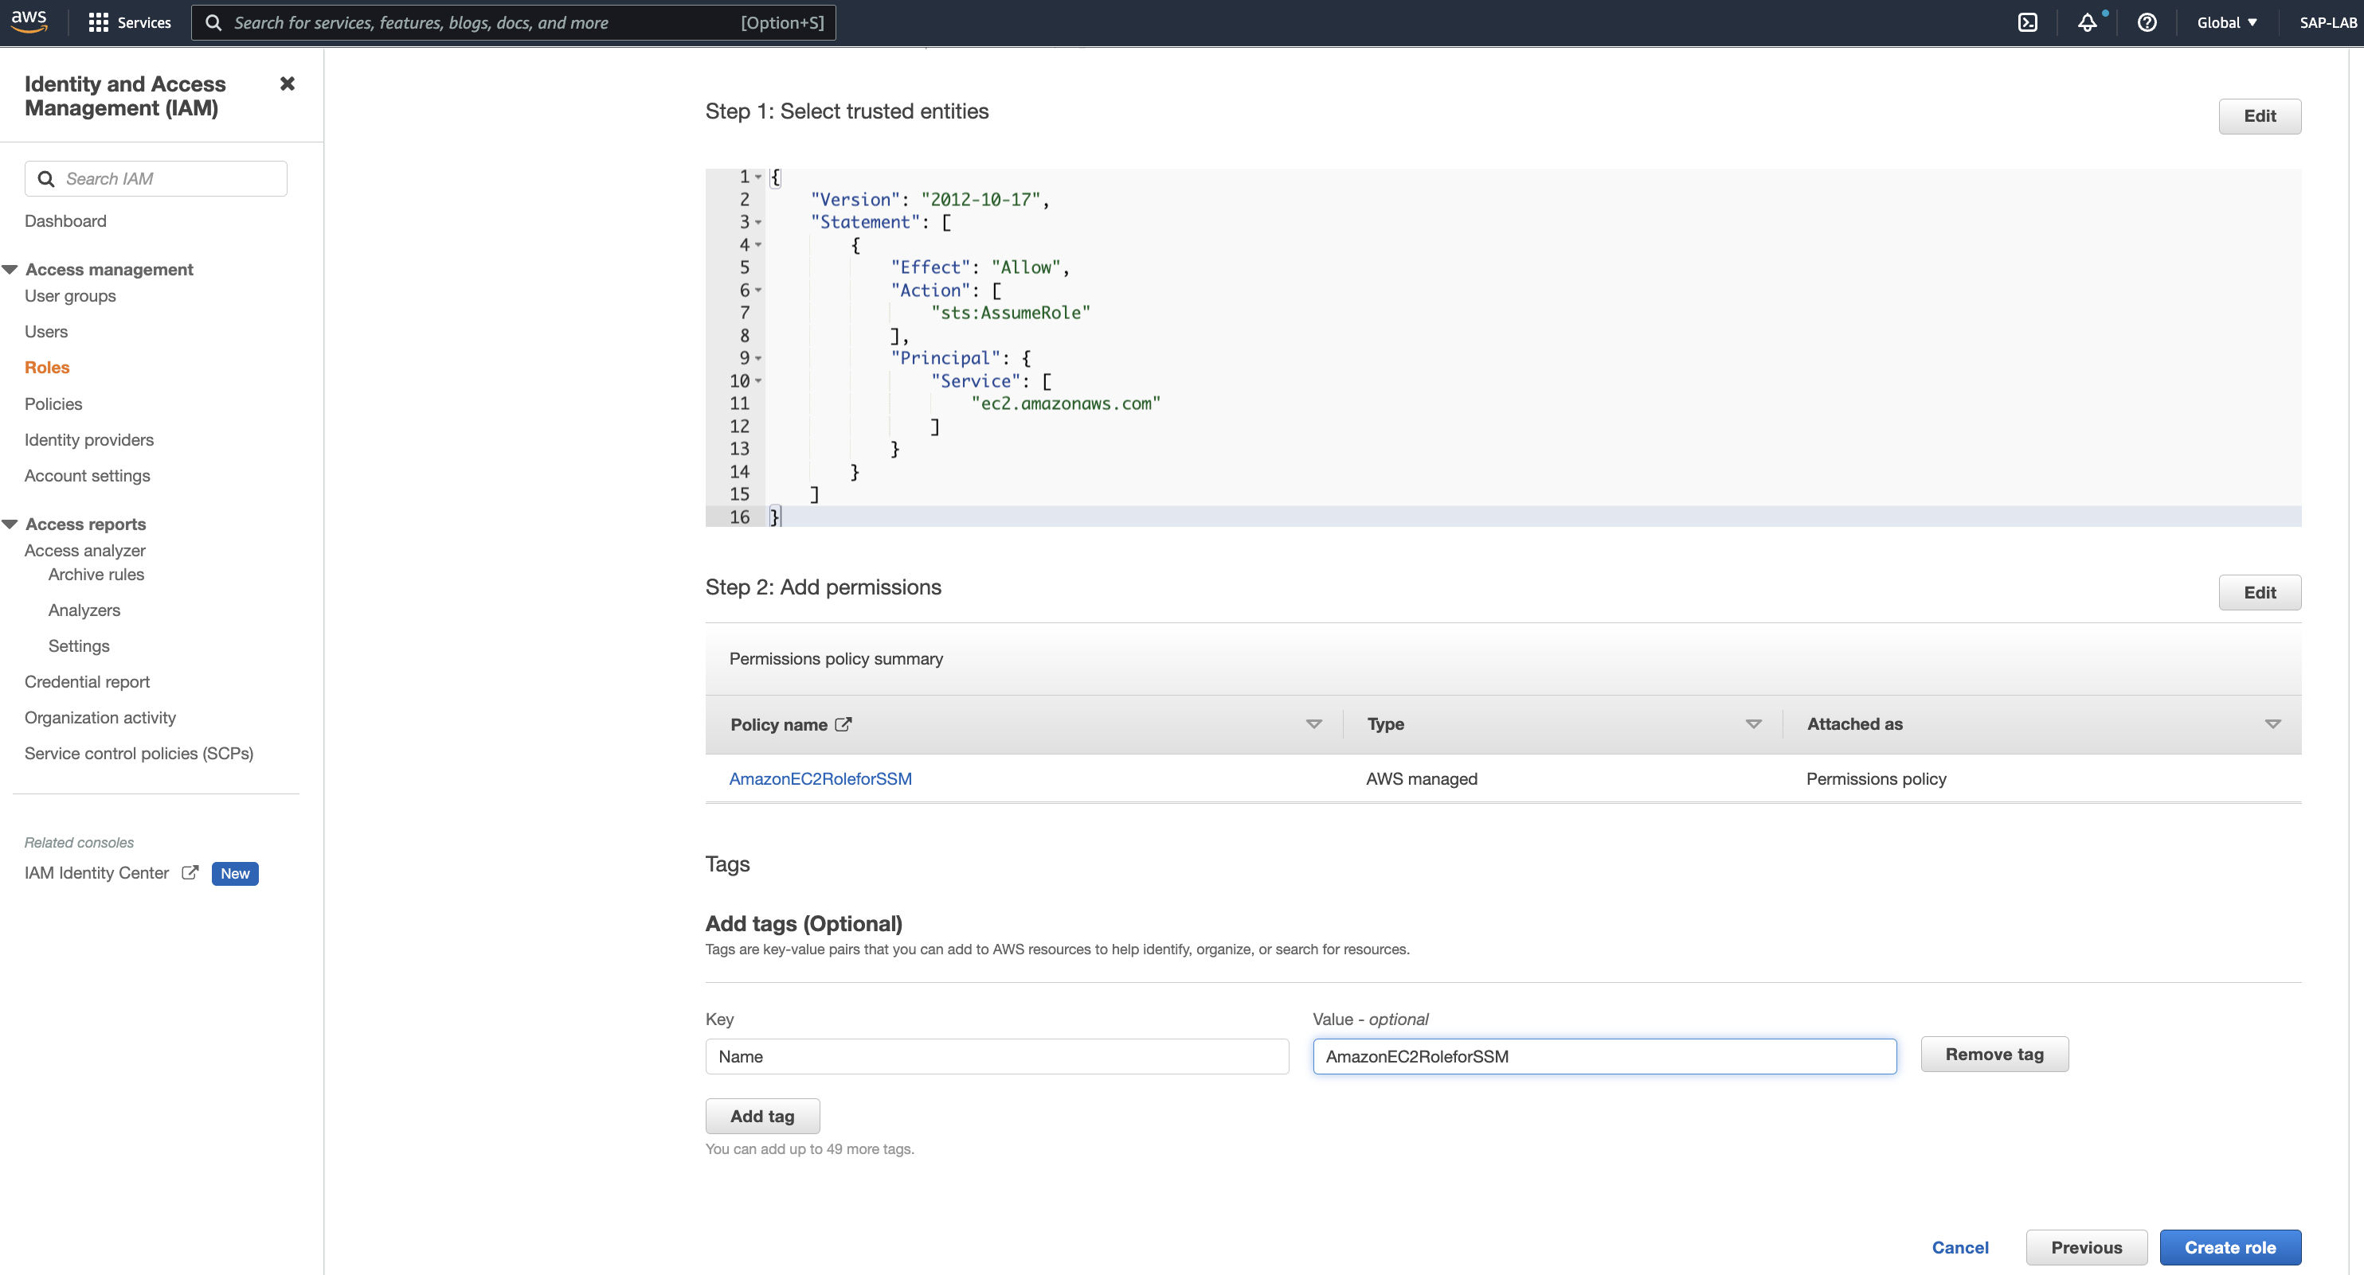

Step 5: Go to EC2 dashboard click on **Launch Instance,** while creating instance under IAM Profile, select the created role in above steps.

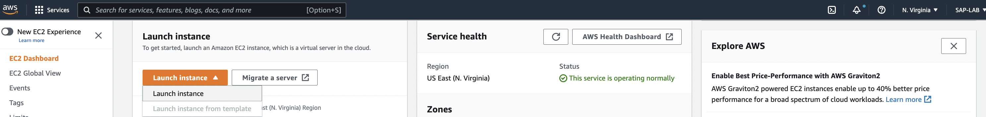

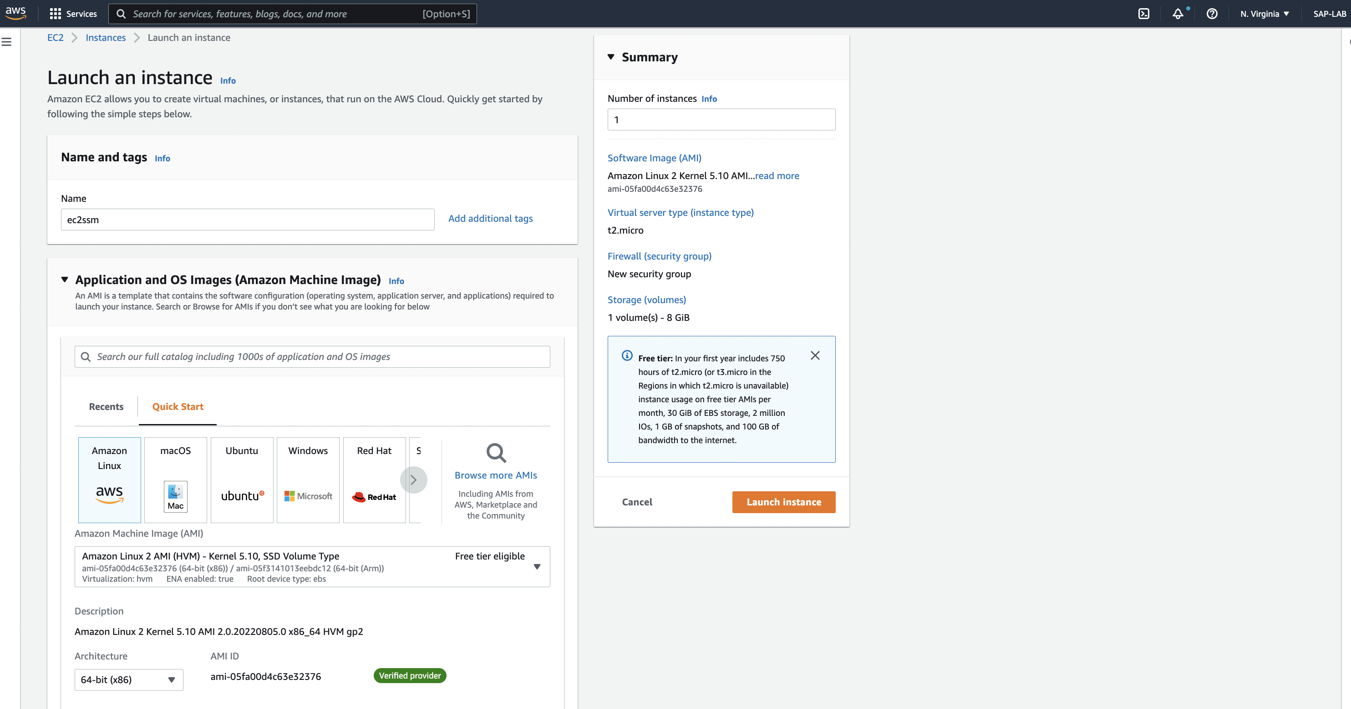

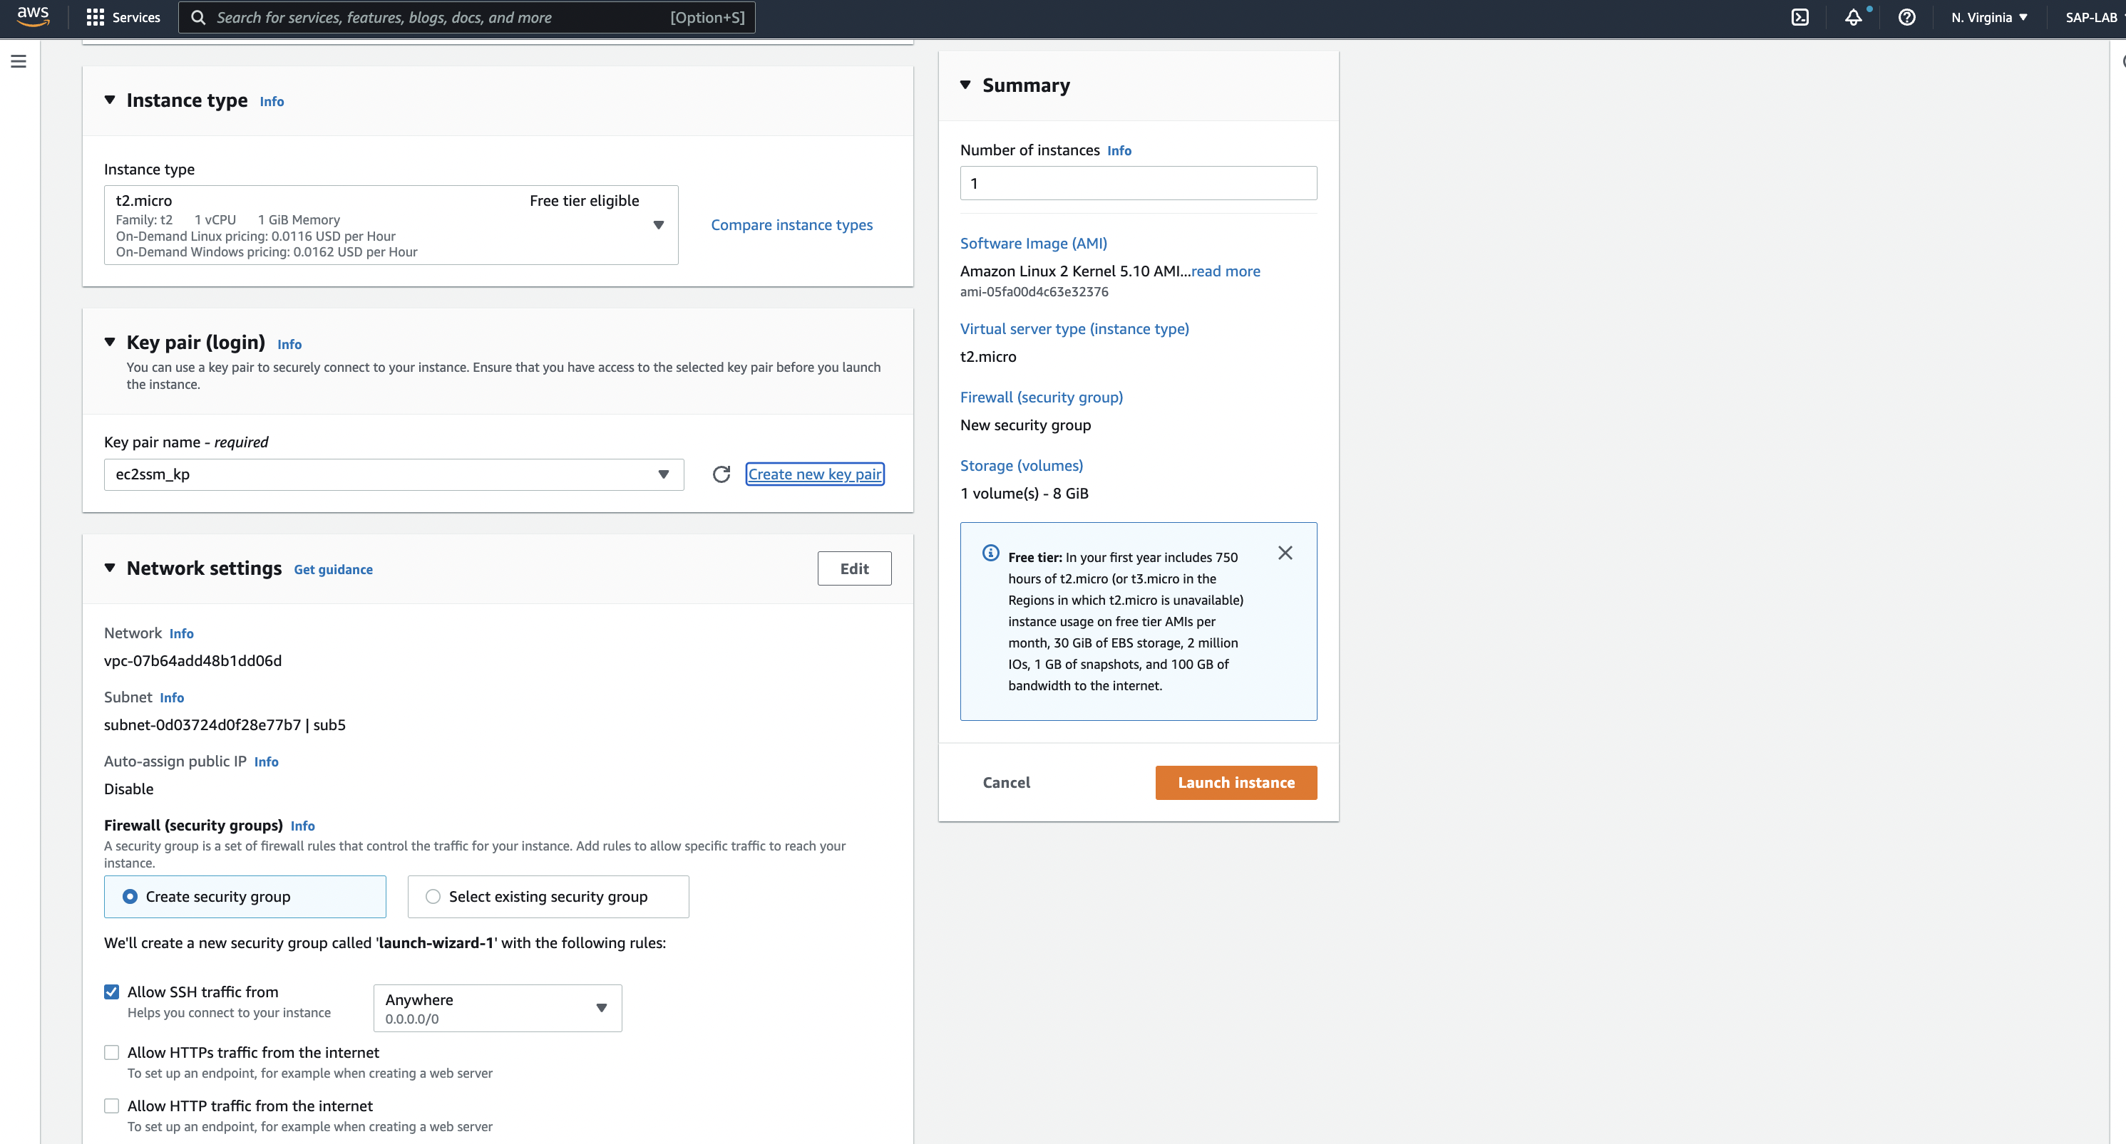

Under Advanced setting select the IAM profile created before. And click on launch instance.

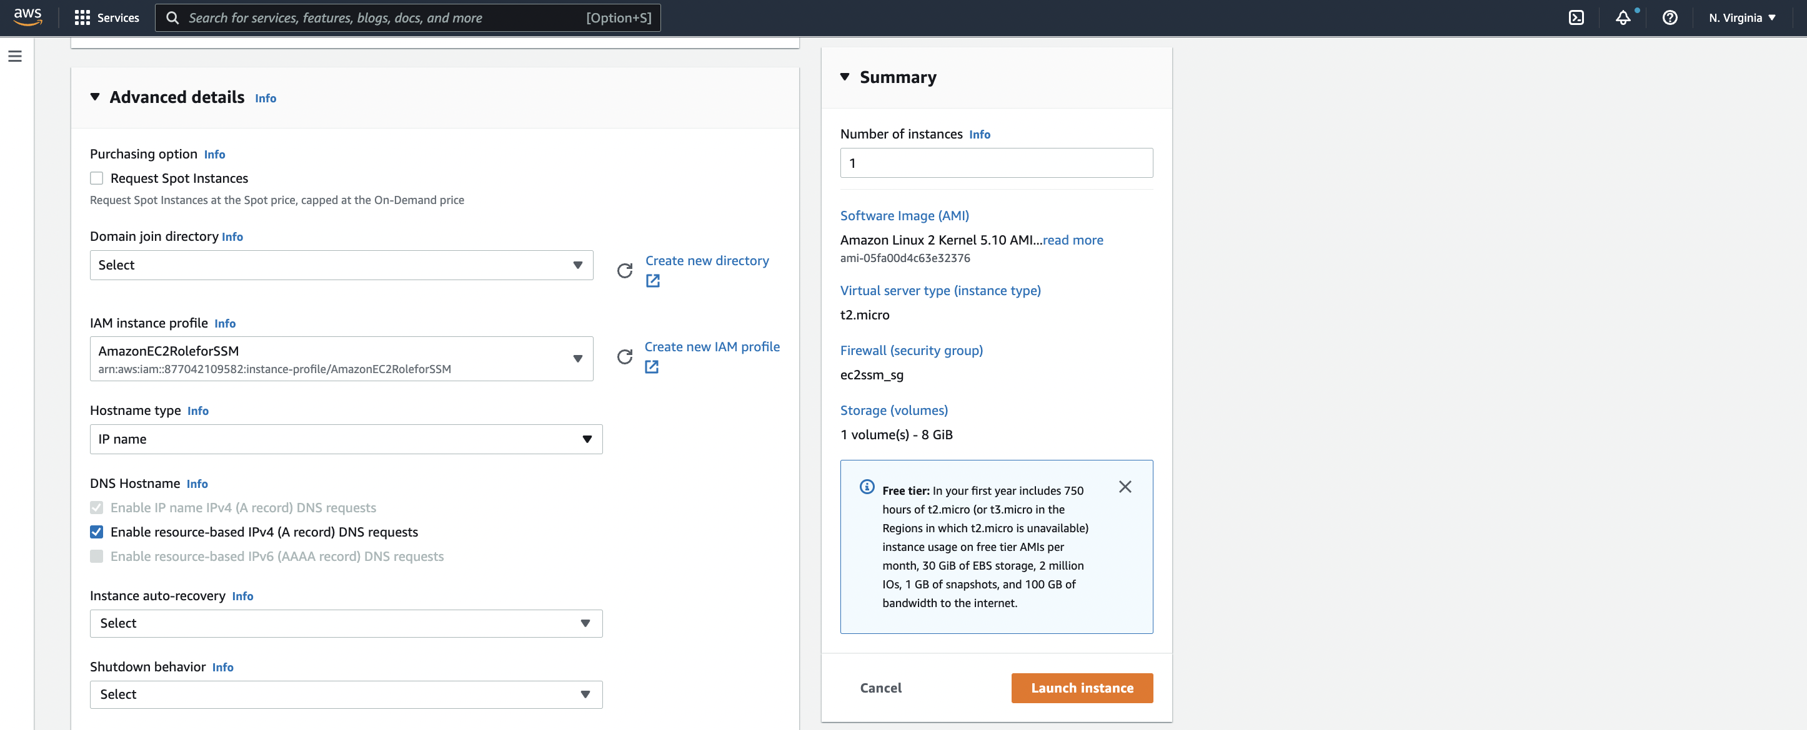

Step 6: Go ‘**System Manager’** dashboard, click on **Quick Setup** and click on **Get Started:**

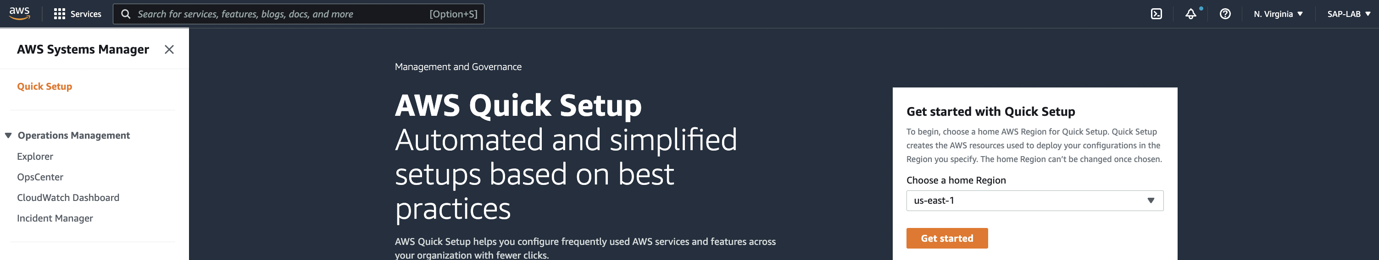

Step 7: Click on ‘**Create’** Host management

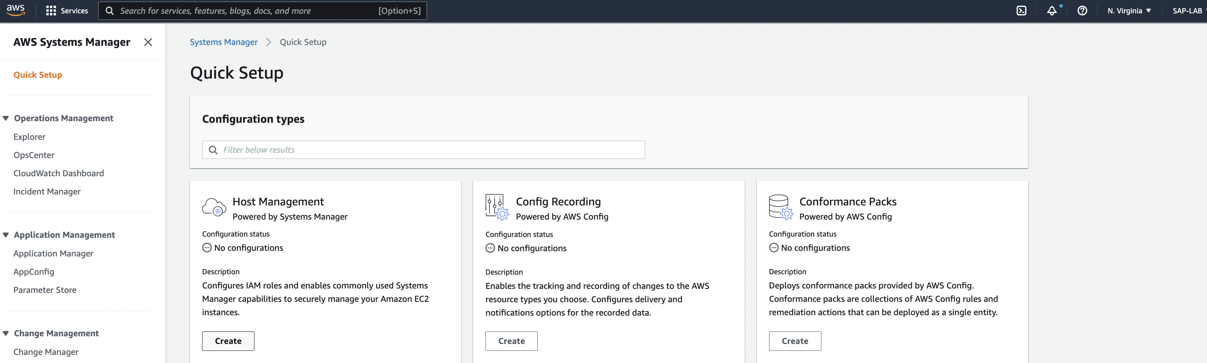

And configure the below properties:

1. Configuration properties – leave the configuration properties as it is
2. Targets – Choose Current account(in case multiple account in OU)
   1. Click on choose region to copy instance
   2. Click on all instance(if you know only 1 instance is running) else click on ‘Tag’ to select the instance.
3. Select the current region and click on create.

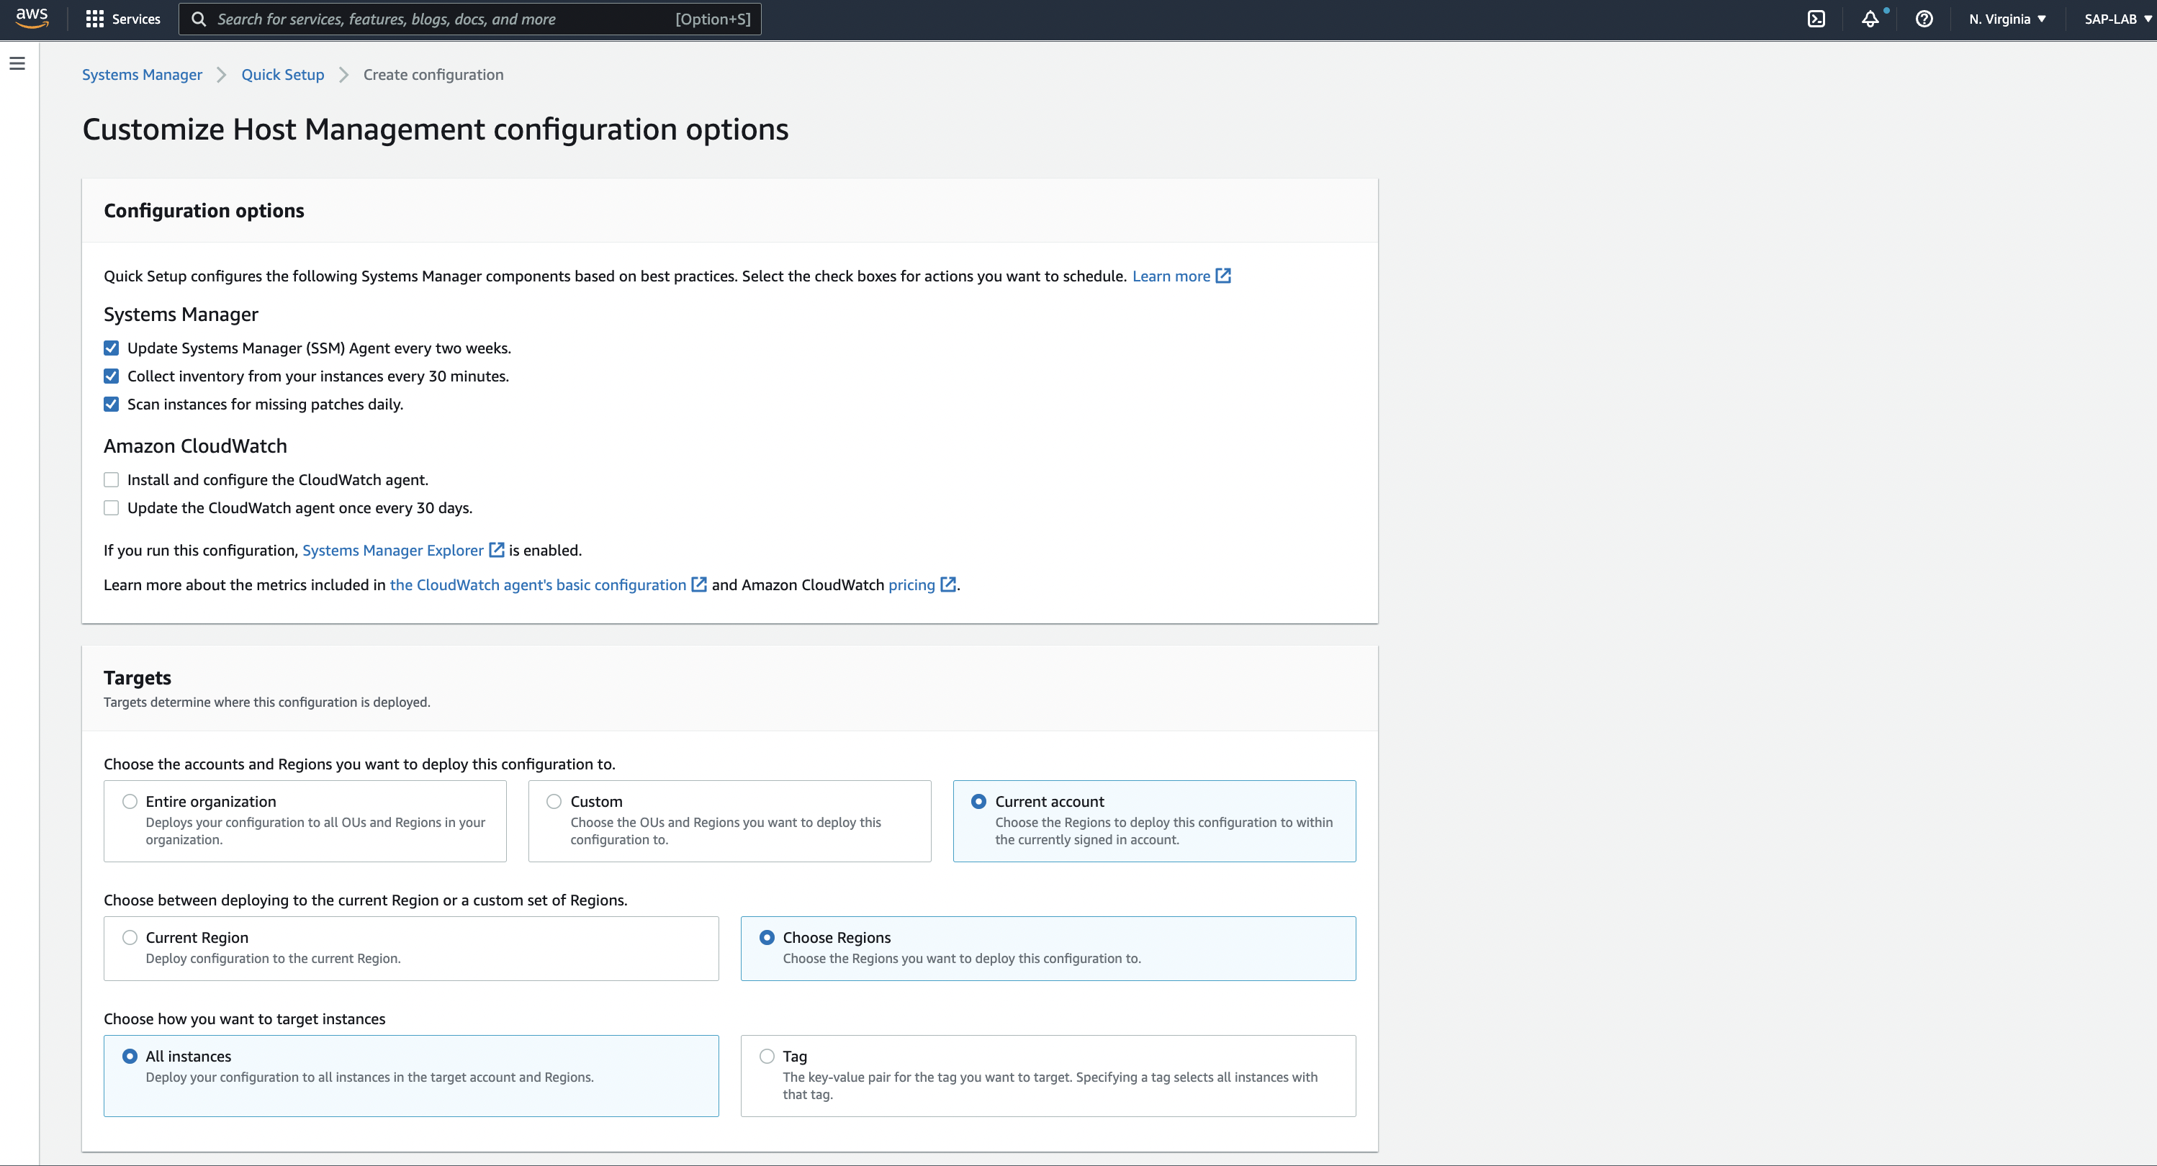

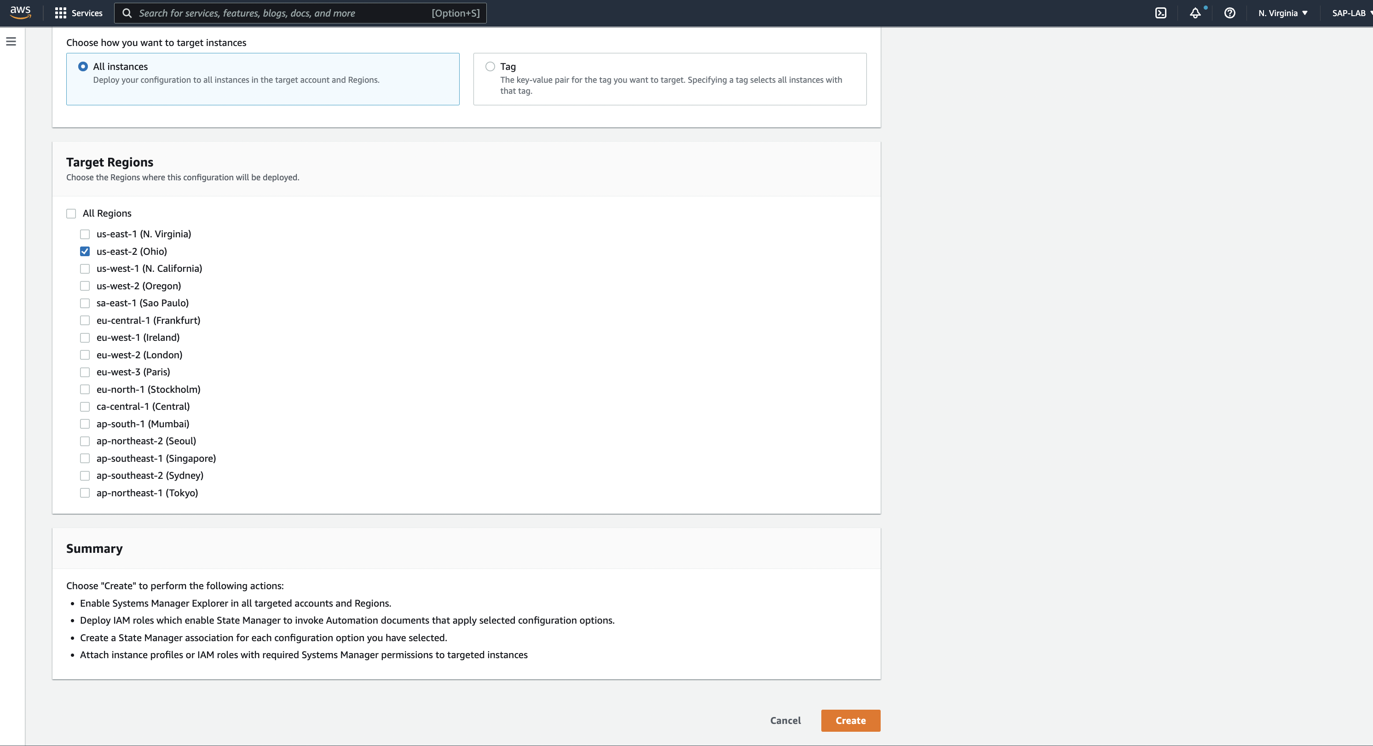

We can see the successful creation status.

Step 8: Click on ‘**Document’** on left side pane and look for **AWSSupport-CopyEC2Instance document**.

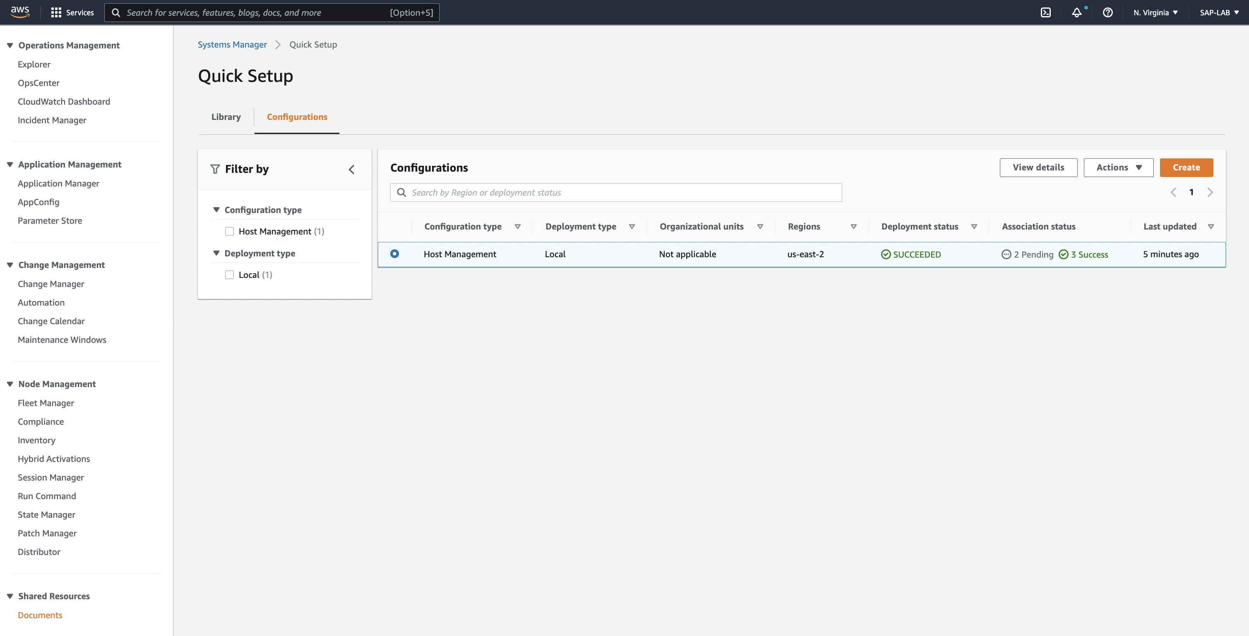

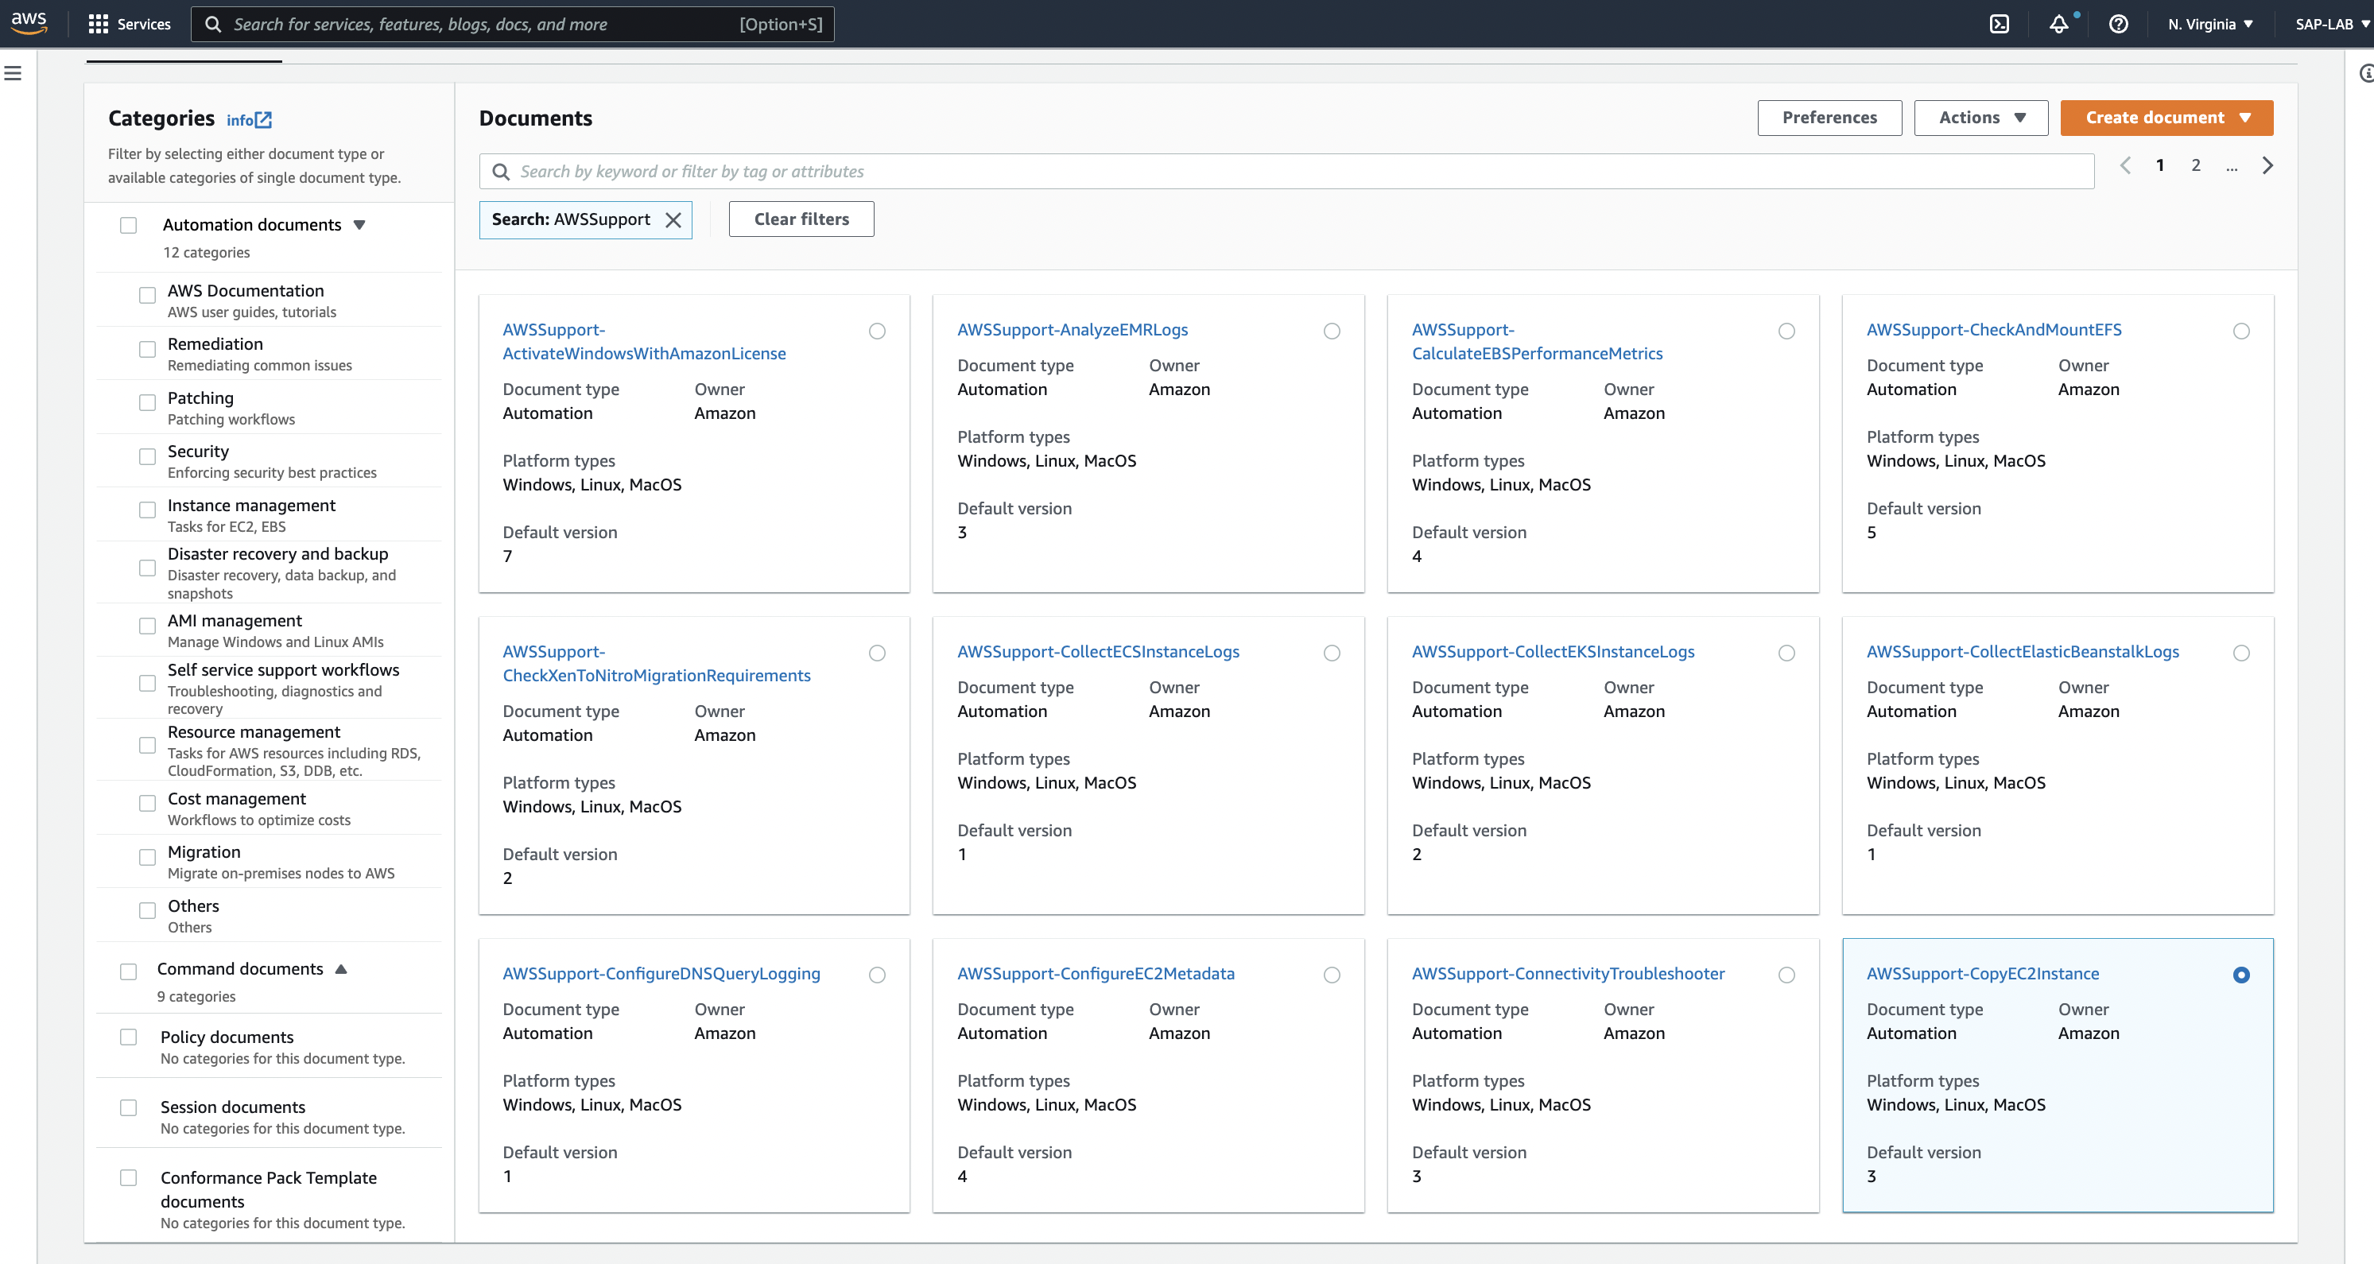

Step 9: Click on ‘Execute Automation’

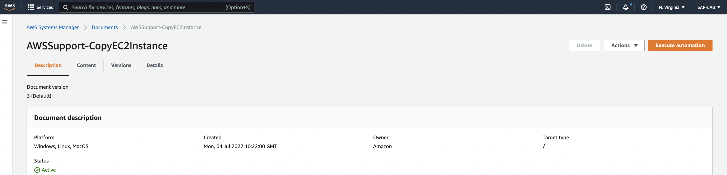

Step 10: Click on ‘simple execution’ and configure below details and click on ‘execute’

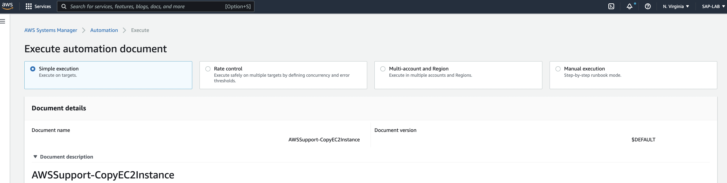

Select the region to copy instance and instance id and click on ‘**Execute’**.

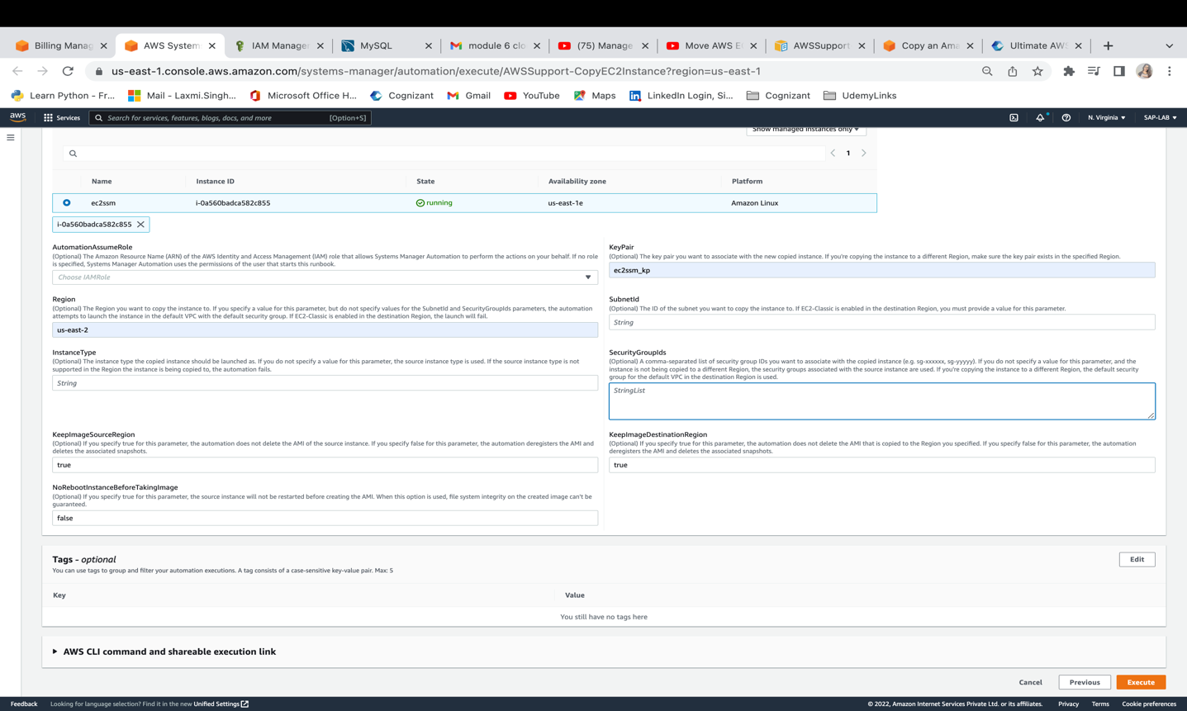

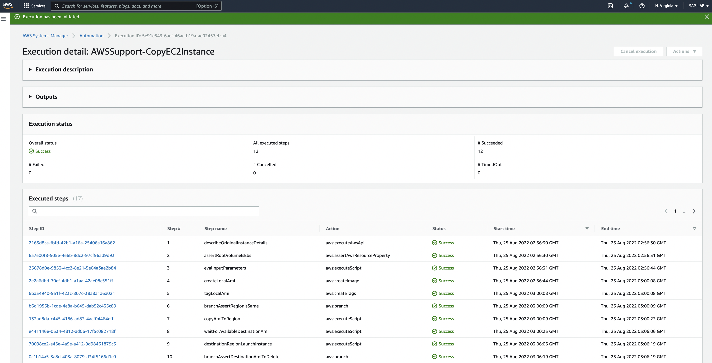

On successful document execution, we will be able to check instance in ‘us-east-2’ Ohio region

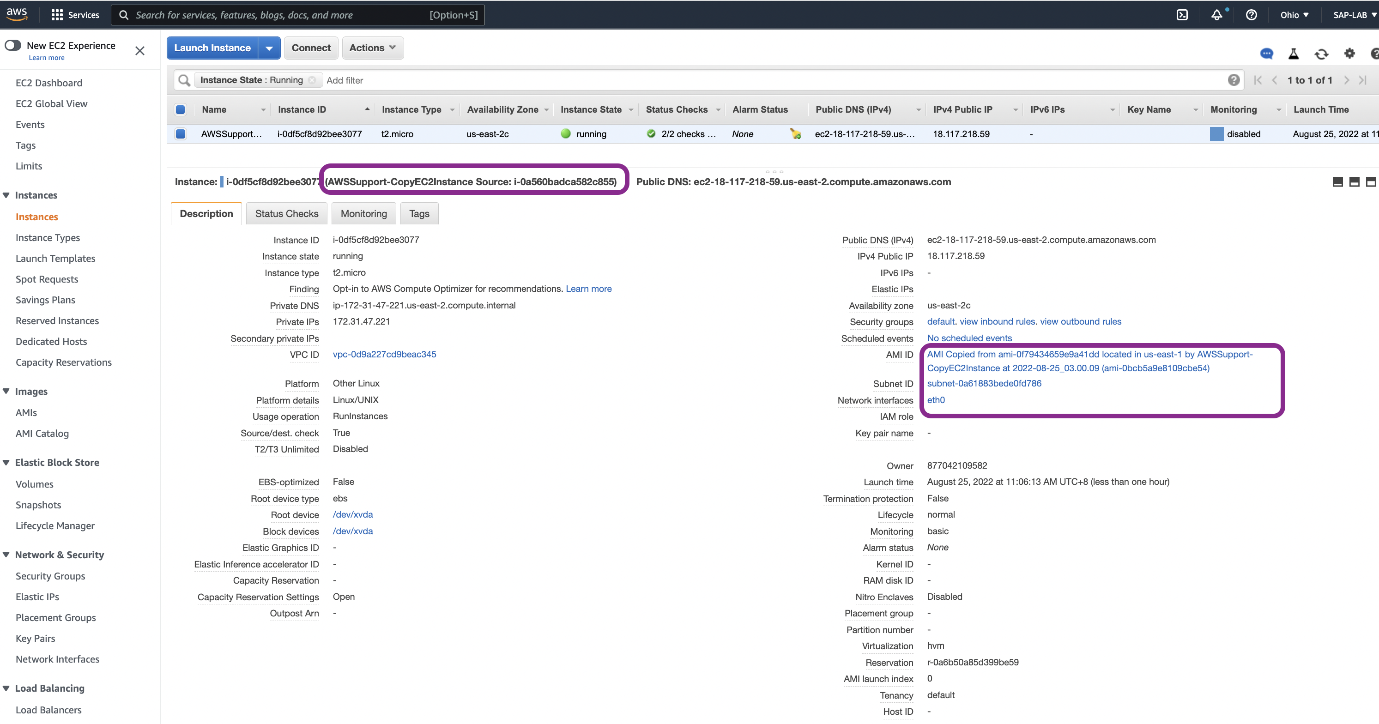

## Task 2 - Manually copy an instance and a launch a new instance from the copy

Below are the steps:

Step 1: Select the desired EC2 instance to create a custom AMI, click on **‘Actions’** and then click on ‘**Image’** from list of actions and then click on **‘Create Image’**

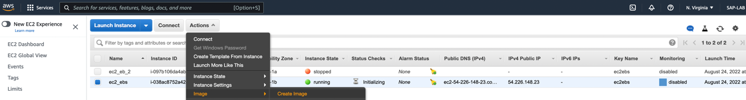

Step 2: To create AMI follow the configuration as below:

1. Image name – put the name for AMI
2. Description – provide the description for AMI
3. No reboot – Enable it. To avoid instance reboot on image creation.

Click on **‘Create Image’**.

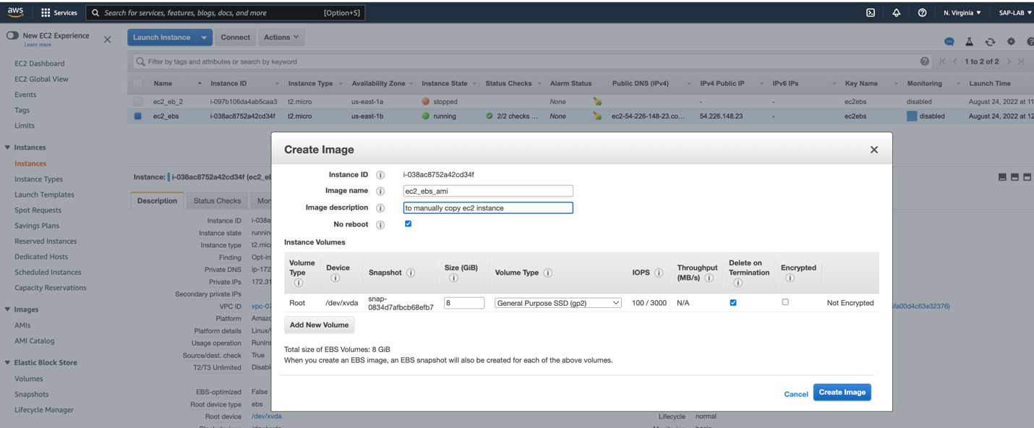

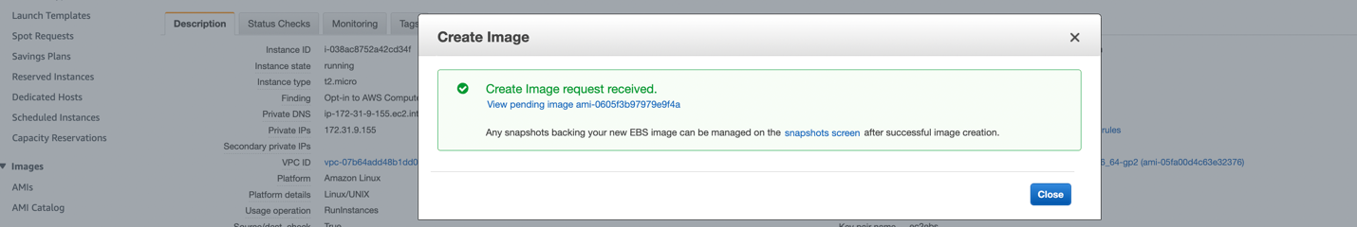

Step 3: Click on the **AMI** from left side pane on EC2 dashboard. And select the AMI and click on ‘**Actions’** and select **‘Copy AMI’**

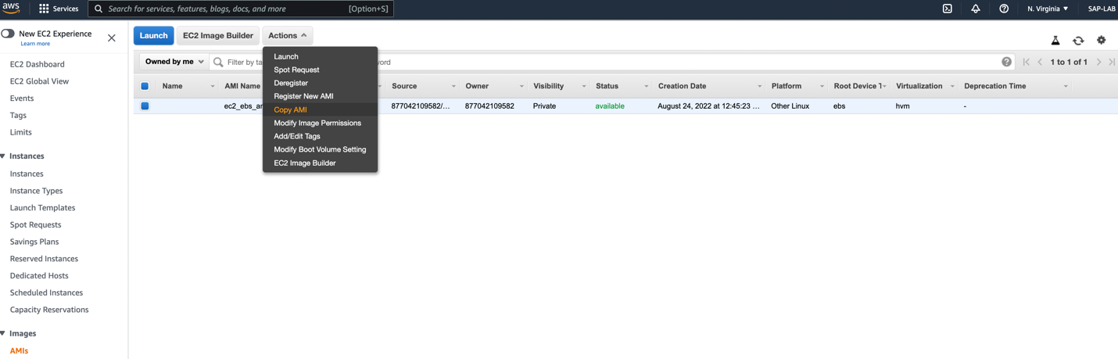

Step 4: Select the ‘Destination region’ and leave the name and description as it is and click on ‘Copy AMI’.

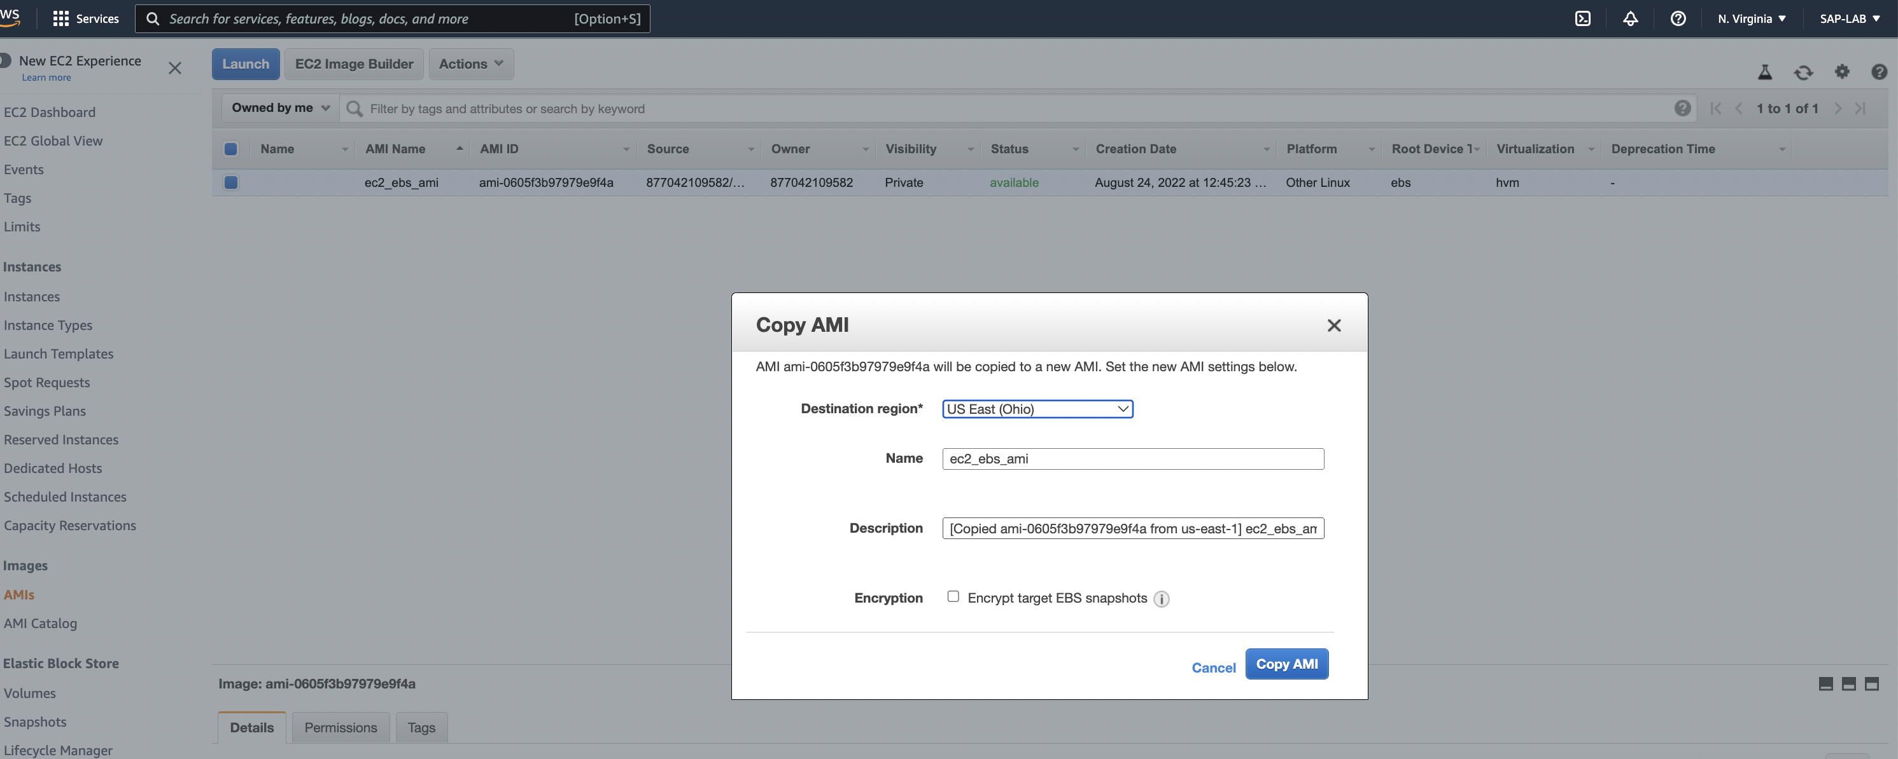

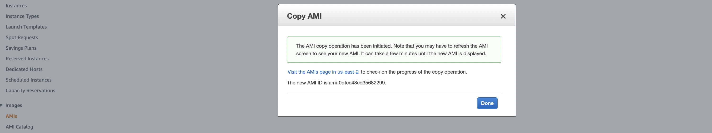

As successfully AMI has been copied. Change the region to ‘Destination region’ in AWS Console. In our scenario its ‘Ohio’.



Step 5: In Ohio region, On EC2 console, click on ‘AMI’ in left side pane. Select the AMI and click on Launch.

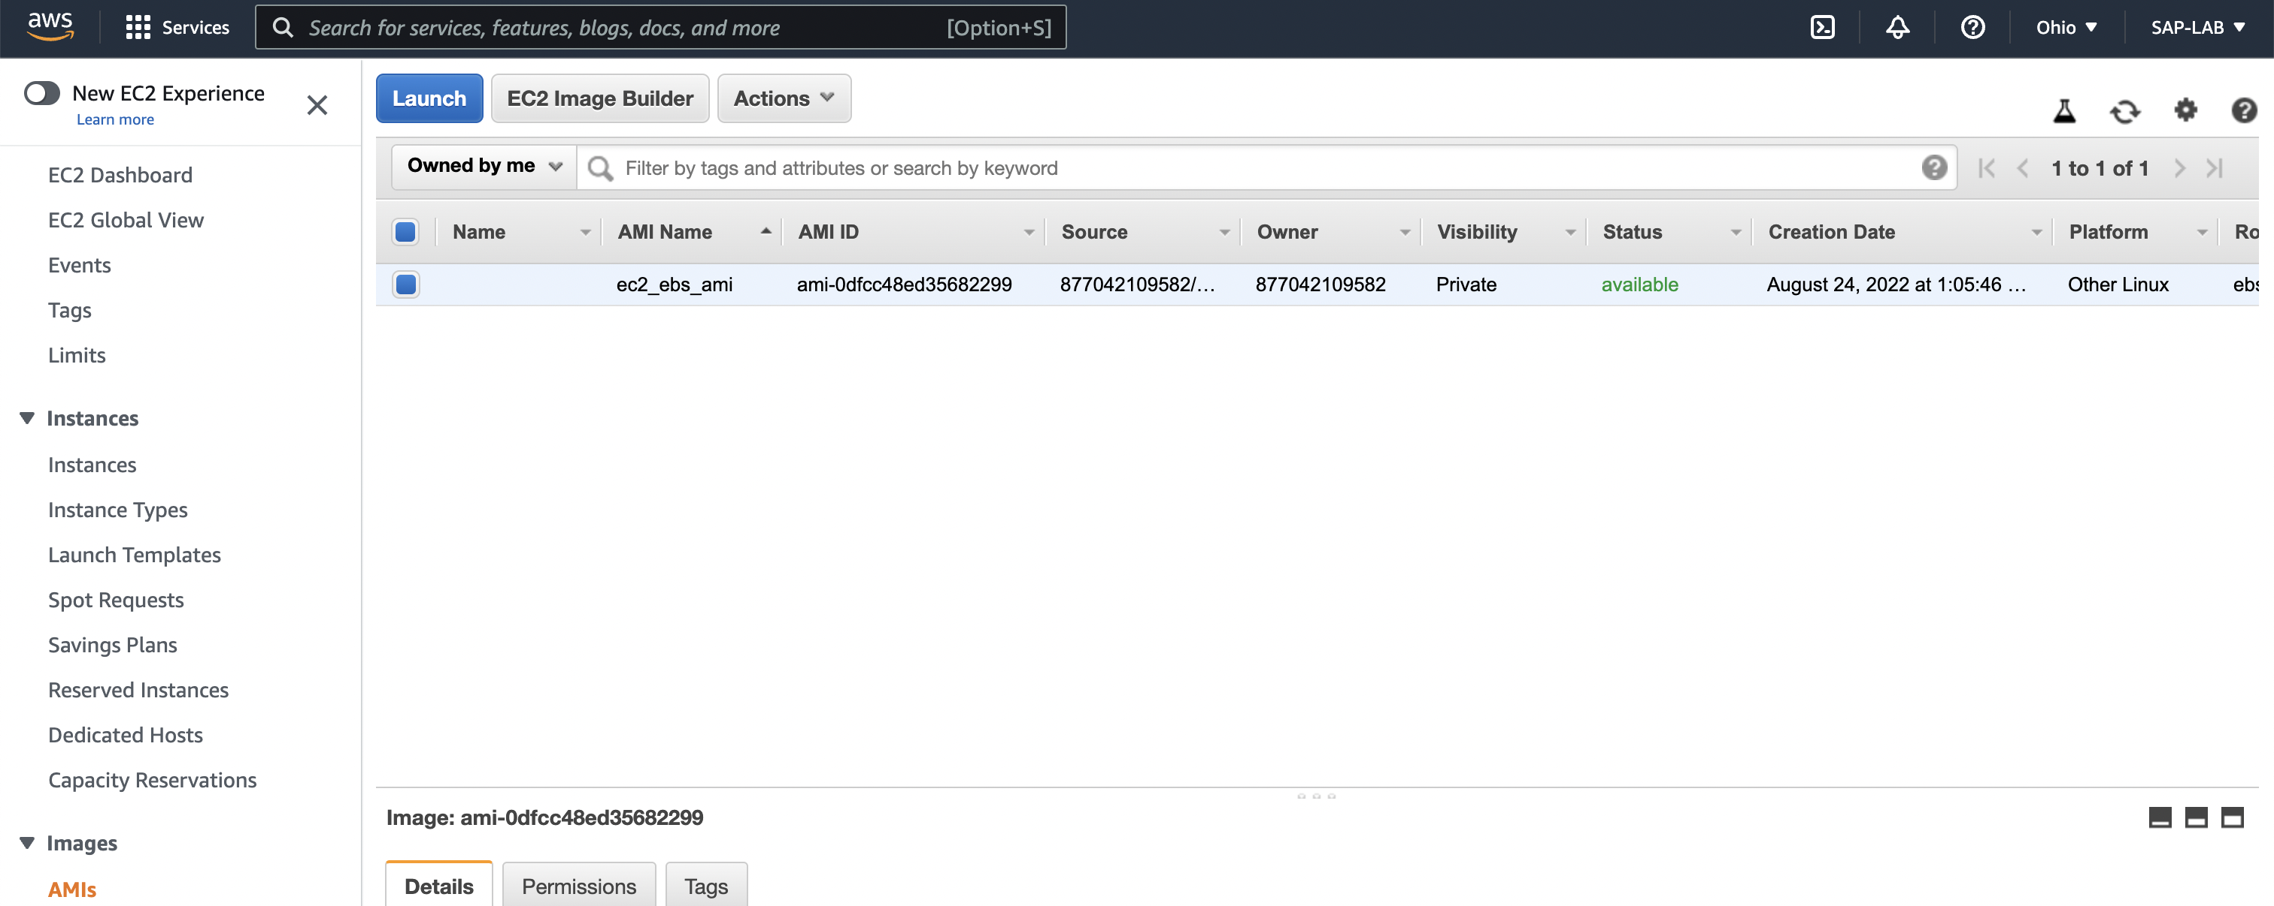

Step 6: Configure the properties if required as below:

1. Name – provide the name for instance
2. AMI is being used already no need to select any.
3. Instance type- leave it as it is.
4. Key-pair – create a key-pair and be mindful of its stored place.
5. VPC, Subnet – If required we can opt another VPCs else default one will be used for VPC and subnet will be selected from any of available subnets.
6. Security group – Create new security group (we can opt default one also).
7. Storage Configuration – Leave it as it is.

Click on **‘Launch Instance’.**

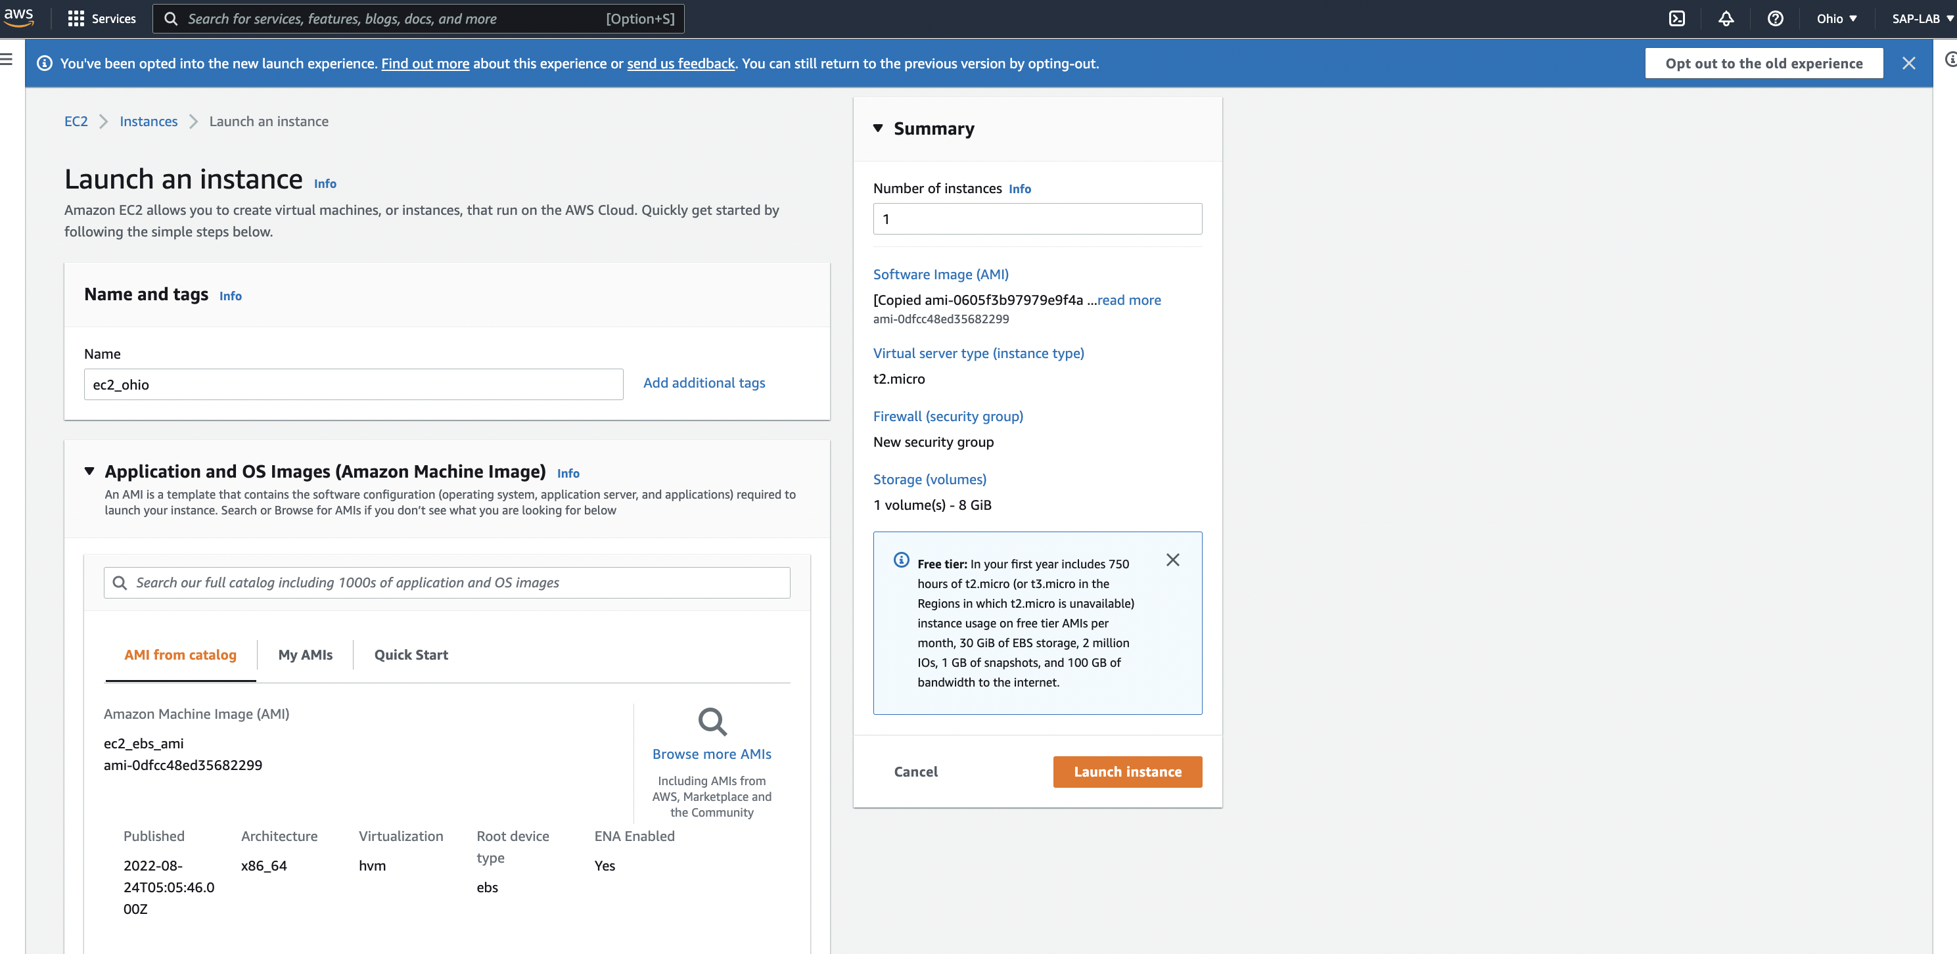

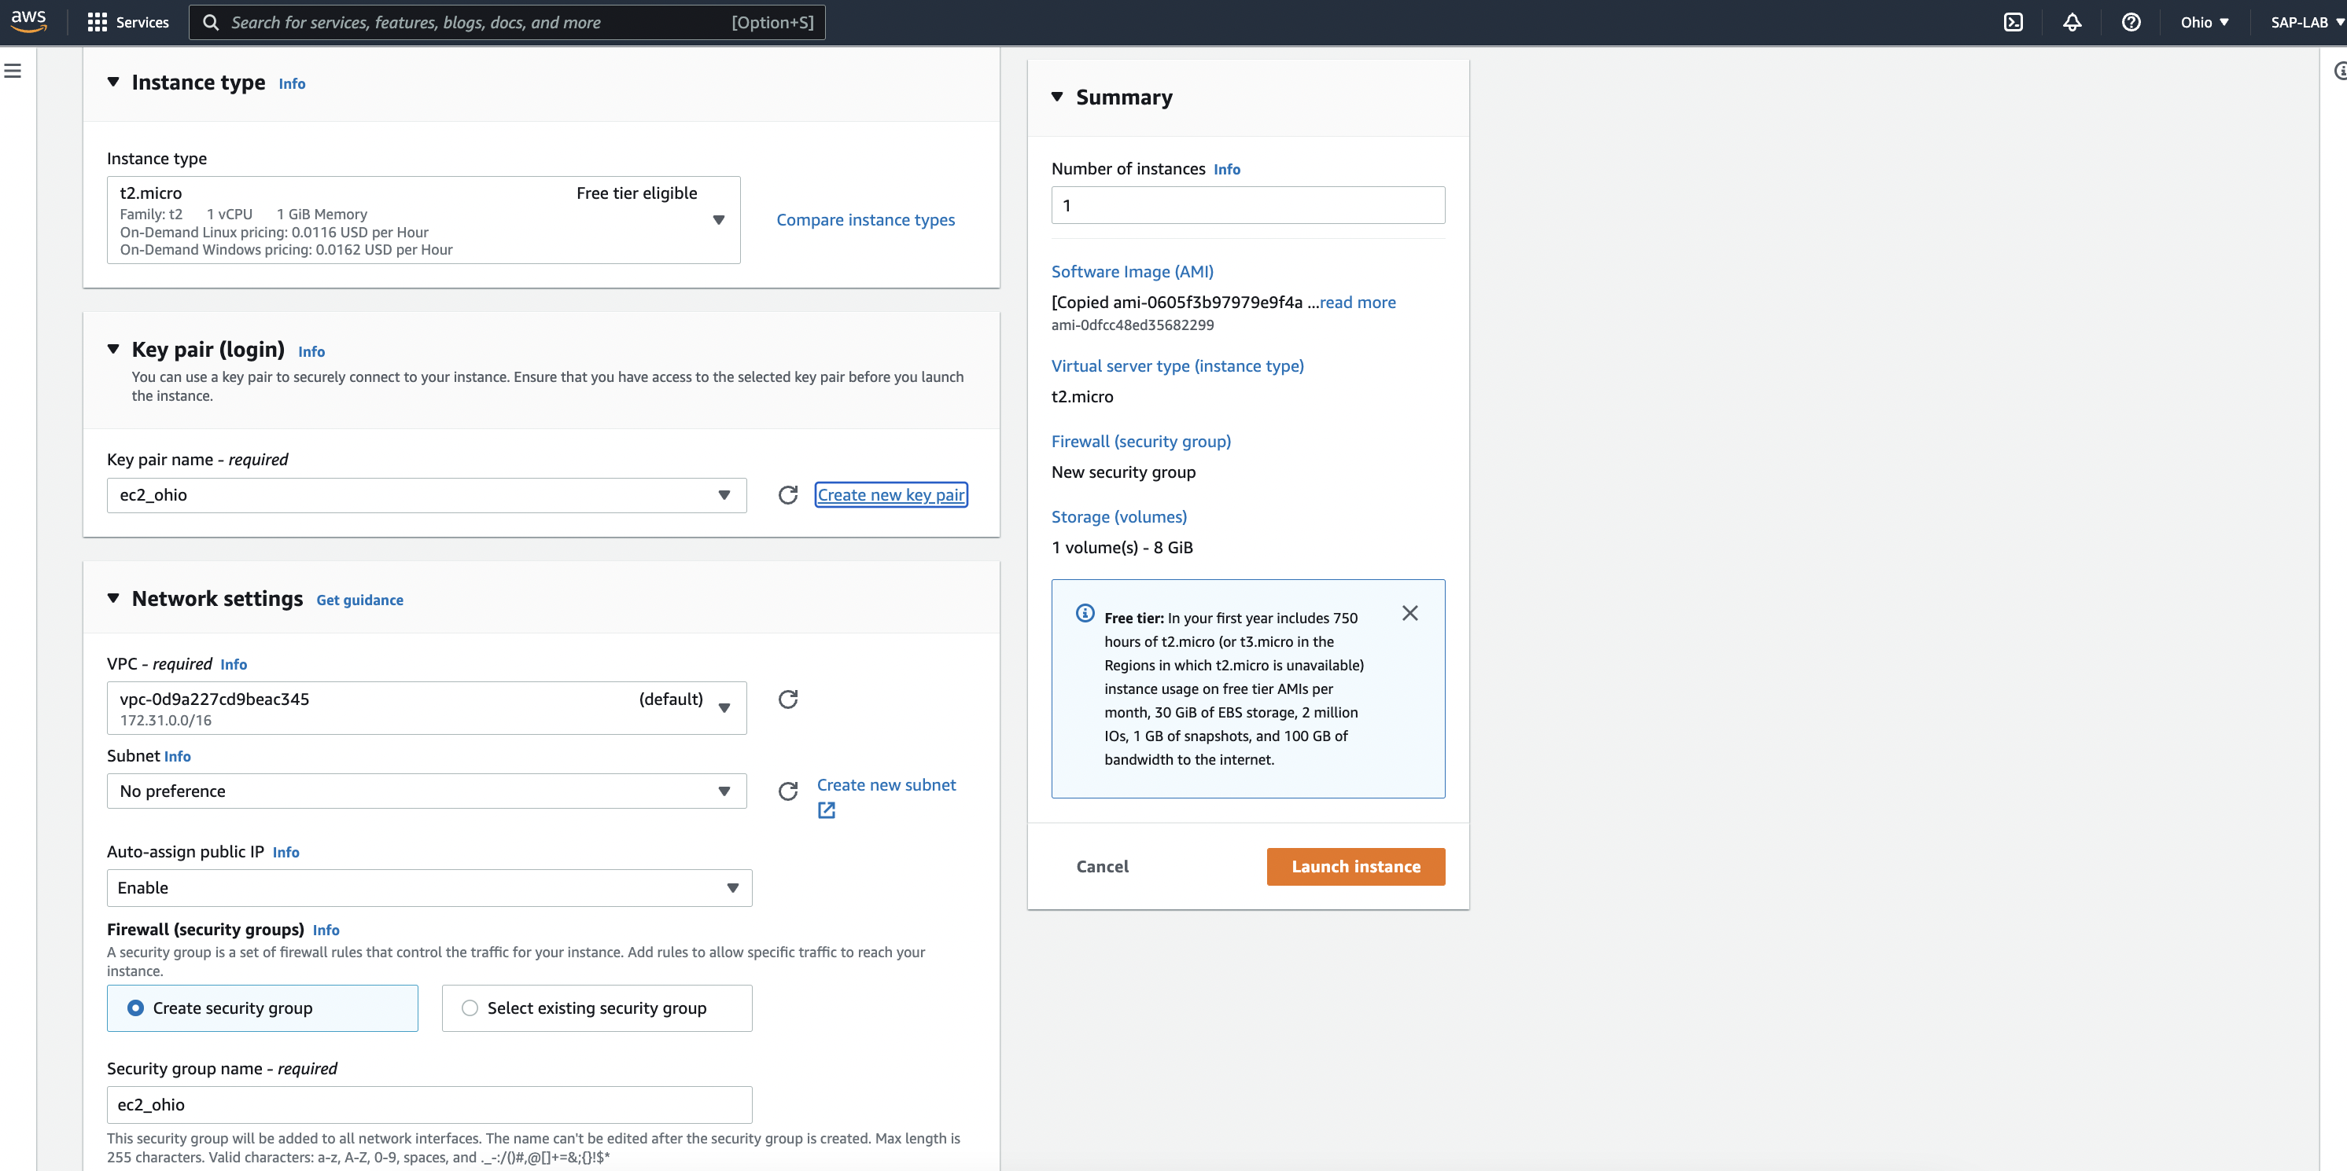

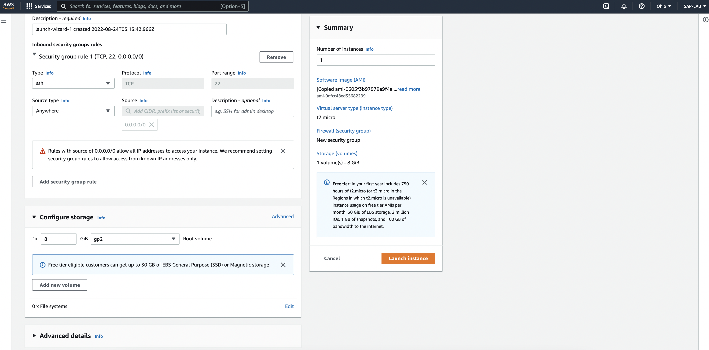

Check the status of instance, if running and health checks are passed, we have copied instance successfully.

